EXPERIMENT: Jira Agile Project Management

AIM
To create and manage a Scrum-based software development project using Jira by creating epics, user stories, tasks, sprints, issue dependencies, and an active project board.

THEORY
Jira is an Agile project management tool used to plan, track, and manage software development activities. In the Scrum methodology, a project can be organized into different levels such as Roadmap, Epics, User Stories, and Tasks/Sub-tasks.
An Epic represents a large project initiative, while User Stories describe functional requirements that provide customer value. Tasks represent specific activities required to complete the work.
Jira also provides a Backlog for managing issues and a Sprint for selecting a set of tasks to be completed within a specific time period. Issues can be linked to show dependencies between tasks. The active sprint is managed using a board with columns such as To Do, In Progress, Review, and Done.

PROCEDURE

1. Create Jira Account
- Open Jira and select Get Jira for free.
- Register using an email address and verify the account.
- Enter the required account details.
- Select Software Development as the work type.
- Select Scrum as the methodology.

2. Create Project
- Create a new Scrum project.
- Enter the project name as Sheify Website Development.
- Open the created project.

3. Add Team Members
- Open the Team/People section.
- Enter the email addresses of collaborators.
- Set the required permissions.
- Click Add people.

4. Create Epics
Create the following two epics:
- Improve Customer Service
- Increase Product Page Conversions

Create Issues

Issue Type | Summary | Parent Epic
Story | Provide live chat as a feature | Improve Customer Service
Task | Add WhatsApp chat to our website | Improve Customer Service
Task | Add Facebook messenger chat to our website | Improve Customer Service
Story | Create a video based knowledge base | Improve Customer Service
Story | Create a review based system for collecting reviews | Increase Product Page Conversions

6. Create Issue Dependencies
The Provide live chat as a feature story is dependent on the completion of the WhatsApp and Facebook Messenger tasks.
Use the Link issue option and select is blocked by to establish these dependencies.

7. Configure Sprint
- Open the Backlog.
- Select Scrum Sprint 1.
- Edit the sprint.
- Set the sprint dates from June 03 to July 01.
- Set the sprint goal as:
“Improving our customers experience on our website.”
- Move the following issues into the sprint:
  - Provide live chat as a feature
  - Add WhatsApp chat to our website
  - Add Facebook messenger chat to our website

8. Start Sprint
- Click Start Sprint.
- Confirm the sprint.
- The sprint will open as an Active Board.

9. Add Review Column
- Open the active sprint board.
- Add a new column named Review.
- Place it between In Progress and Done.
The final workflow becomes:
To Do → In Progress → Review → Done

10. View Project Information
The project can also be viewed using:
- Timeline View – displays epics, tasks, dates, and dependencies.
- List View – provides a spreadsheet-style view of issues.
- Dashboards – provide project tracking and reporting.

RESULT
The Sheify Website Development Scrum project was successfully created in Jira. Epics, stories, tasks, issue dependencies, and a sprint were configured successfully. The sprint was started and a custom Review column was added to the active board.

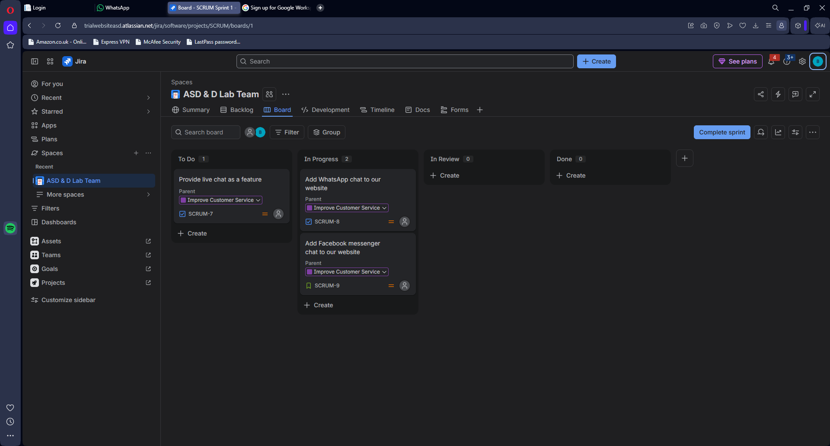

CONCLUSION
Thus, Jira was successfully used for Agile Scrum project management, including project planning, backlog management, sprint planning, issue tracking, dependency management, and progress monitoring.

